Trainee Instructions for eCase

VETERAN - LESTER MILLSTONE - FILE NUMBER: 6Y29XXOO

In processing this claim you will consider the following actions to already be completed:

* You will have limited access to update systems compliance issues while processing eCases. Specifically, any system compliance issue that must be updated utilizing SHARE, such as Corporate Flashes, cannot be processed at this time. Any information that can be entered in VBMS Demo will be your responsibility to update and issues that require the use of SHARE will be annotated on your Development Checklist as completed.
* If direct deposit information is included on the VA Form 21-526EZ, you will treat the case as if a voided check was attached verifying the routing and account number. Then update VBMS Demo as required.
* All documents are certified, unless otherwise noted.
* Any historical documents that may be provided (DD 214, STRs, Entrance and Exit Exams), are to give you necessary information to process the claim. Do not allow historical inaccuracies to divert your attention from processing the claim.
* If by chance, there is already an EP associated with the claim, continue to CEST a new claim.

Using all available systems and given the set of documents, the trainee will develop the following claim.

You must CEST the claim prior to uploading any documents. You must also assign the claim to yourself.

**Please Note:** You are being provided several documents that you will utilize to process this claim. All documents are contained in a single PDF. You will upload the PDF document and label as follows:

Subject: VA Form 21-526EZ with additional documents

Category – Type: Applications – Original Claim: VA 21-526EZ, Fully Developed Claim (Compensation) Content Source: VBMS

Date of Receipt – date of receipt on the 21-526EZ

**The PDF contains the following documents for your review:**

* VA Form 21-526EZ
* DD 214 (submitted by Veteran)
* CAPRI Enterprise Search
* VIS Military History (VADIR) Screenshot

**ADDITIONAL INFORMATION REGARDING SERVICE RECORDS**

* **JOINT LEGACY VIEWER:** Assume a review of Joint Legacy Viewer (JLV) is absent of any active duty or Reserve Service Treatment Records. There are no medical records available.
* **DPRIS:** Assume you request and upload all personnel records via DPRIS. A review of the records shows same DD Form 214 as the Veteran submitted, active duty and Reserve administrative records, however there is no indication of a Line of Duty (LOD) report in the records.
* **VBMS:** (See the below screenshot of the Obtain STRs status message in VBMS)

**DIRECTIONS:**

1. This claim will be processed in the VBMS Demo environment.
2. Review each scenario using the most current laws, rules, and regulations
3. ALWAYS use the VA File number, NOT the SSN
4. Use your assigned “Y” and “XX” number
5. Properly label and establish date of receipt. All documents have simulated dates stamps. You will need to determine the correct date of claim
6. Bookmark medical and dependency documents (if appropriate)
7. Order STRs/Personnel records (if appropriate)
8. Generate/Create any letters necessary for the claim (if appropriate)
9. Order Exams (If appropriate).
   1. If exams are required for NEW conditions, order the exam in VBMS Demo.
   2. If exams are required for INCREASE conditions, use ERB to build the exam, regardless of what the ERRA directs – this is because VBMS Demo does not have the capability of completing an increase exam due to system issues.
   3. If the claim is a combination of new and increase conditions, use ERB.

**NOTE**: When using the ERB tool, the system will ask you if you would like to create a tracked item for the exam in VBMS. Since you will be using the VBMS Demo environment you will select “No” and will have to go into the system and manually create the tracked item. This is outside of standard policy but must be done because VBMS Demo will not allow ERB to create a tracked item. This is to reinforce that a tracked item must exist for all exams.

**NOTE:** If creating an exam in VBMS Demo, take the following actions:

* 1. Select the Exam chevron on the Claims page
  2. Next to “Create New Request” – Select the fly wheel
  3. Put a check mark in the following box:

1. Use Exam Destination Mock Data
   1. Select the fly wheel to close. If this box is not selected, the system will give you an error message when you try to submit the exam. THIS IS ONLY DONE IN VBMS DEMO, NOT VBMS LIVE MODE.
2. Ensure all tracked items are added.
3. Enter final note into VBMS notes.

**VBMS SCREENSHOT:**

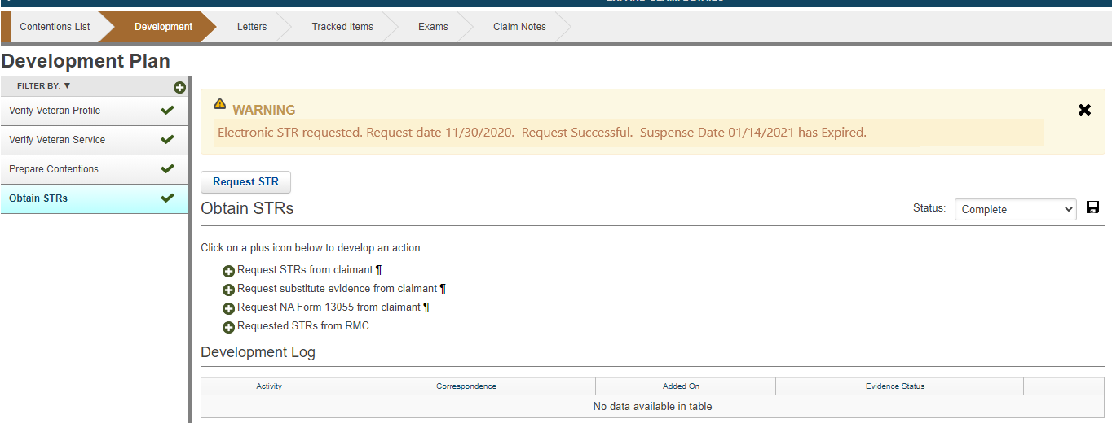

Warning: Electronic STR requested. Request date 10/06/2021. Request Successful. Suspense Date 11/20/2021 has Expired.